Volume

1

Bucks Fire alarm system

Professional, Fail-Safe Fire Alarm System Management

User Manual

**Professional, Fail-Safe Fire Alarm System Management**

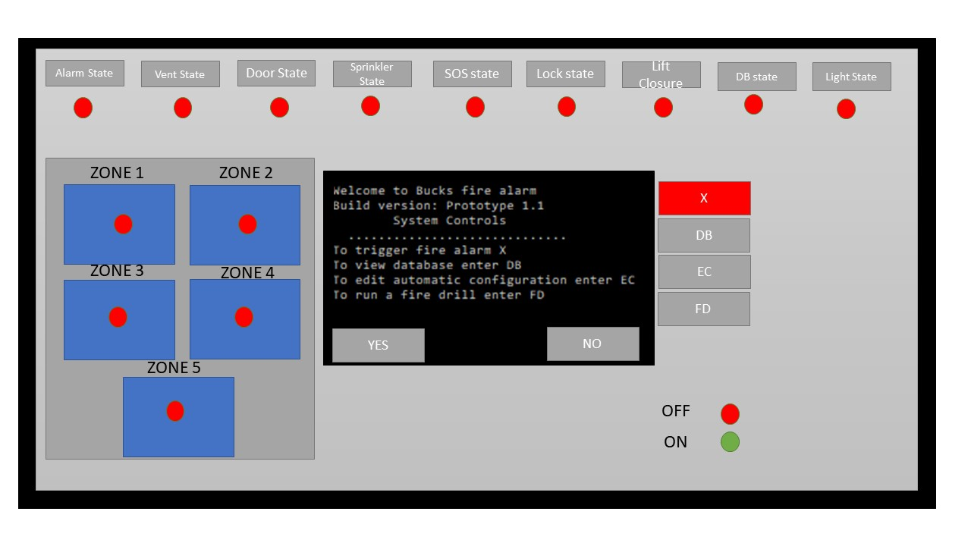Fire Alarm System User Guide

*Figure 1*

© Gilmar Nivesh, Diogo, Leon

Queen Alexandra Rd, High Wycombe HP11 2JZ

Phone 020123456789 • Fax 0206543212

Table of Contents

|  |  |
| --- | --- |
| TABLE OF CONTENTS  Chapter 1 System overview #  Section 1.1 *Unlocking The Panel* #  Section 1.2 Information Displays #  Section 1.3 Zone Information #  Section 1.4 Manual Activation #  *Section 1.5 View Database #*  *Section 1.6* *Edit Configuration* #  Chapter 2 Fire Alarm Activated #  Section 2.1 *Automatic* #  *Section 2.2*  *Automatic demonstration* #  Section 2.3 *Manual* #  Section 2.4 Manual Demonstration #  Section 2.5 *Running a Fire Drill* #  Chapter 3 Database utilization #  Section 3.1 *How to setup USB database saving* #  Section 3.2 *How to setup cloud database saving* # | Chapter 4 Edit configuration #  Section 4.1 *How to operate* #  Chapter 5 error messages and recovery procedures #  section 5.1 *error code: 101 – No wifi* #  section 5.2 *error code: 007 – Alarm not connected* #  section 5.4  *error code: 212 – Module not connected* #  section 5.5 *Error code: 333 – database connection*  #  section 5.6 *Error code: 123 – Incorrect config* #  section 5.7 *error code: 013 – Incorrect pin* #  Chapter 6 forgot my pin #  section 6.1 *how to recover your pin* #  chapter 7 how to install the admin panel #  section 7.1 *How to setup the relay module* #  section 7.2 How to install the relay module #  section 7.3 Relay Module explained #  section 7.4 How to install the admin panel #  section 7.5 back panel explained # |

Chapter

1

System Overview

Thankyou for purchasing Bucks New Uni Professional Fire Alarm Management System, this chapter will explain the overview of the system

t

he product you have purchased is a highly fail safe Fire alarm system developed by Software engineering students at Bucks New University. The following chapter will explain the system overview, explaining the usage and usability of specific features and functions

The following user manual has been written for the intended readership of the operator of the fire alarm system.

This manual is written for software release Prototype: 1.1

If you require immediate assistance, please call us at: 123456789

If you have any questions regarding the fire alarm system, please email: questions@bucksfirealarms.com

List of Functions

Please note that each function can be enabled or disabled via the edit configuration tool explained in chapter 4

Alarms in each room

* + Text based & Visual tracking of such in each room and zone
  + Verification of alarm in each room and zone
  + Error checking if vent opening sequence fails
* Vents on each floor
  + Text based tracking of vent condition and state in each zone
  + Verification of each vent in every zone
  + Error checking if each vent is not closed
* Automatic closing of doors in each room
  + Text based tracking of door state
  + Verification of each door closing in every zone
  + Error checking if doors are not closed
* Sprinkler system in specific rooms
  + Text based tracking of sprinkler state
  + Automatic searching for individuals in sprinkler zone
  + Sprinkler system activate tracking
  + Error checking if sprinklers are not activated
* Emergency services calling (SOS)
  + Text based tracking of SOS system
  + Automatic calling of emergency services
  + Information such as address/time is sent to emergency services
  + Confirmation message when information is sent
  + Error checking system
* Zone locking off
  + Text based tracking of zone locking sequence
  + Automatic searching for individuals in each zone
  + If zones are clear, doors will lock – will be automatically unlocked if personnel detected
  + Error checking if zones are not locked
* Lifts closing
  + Text based tracking of lift closing sequence
  + Lifts will be opened at closest floor
  + Lifts will be out of use
  + Error checking if there is an issue with a lift
* Database logging
  + Text based tracking of database sequence
  + Date/Time and reason (optional) will be logged in database
  + Error checking if there is an issue with database
* Directional lighting
  + Text based tracking of lighting sequence
  + Directional lights leading to closest fire exit will be turned on
  + Error checking if there is an issue with a specific light

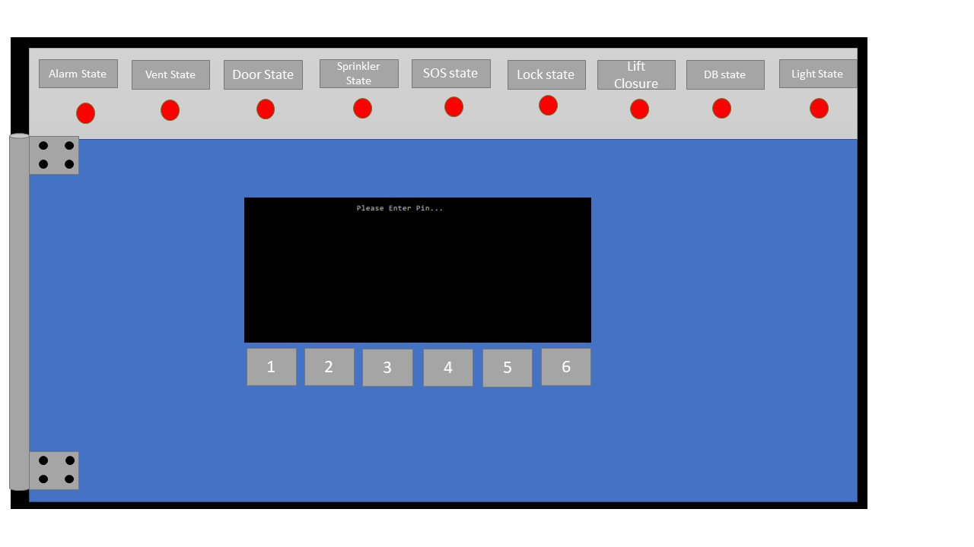

*Figure 2*

# Unlocking The Panel

Once the fire alarm system is installed to unlock and access the fire alarm system management panel you must enter your 6-digit pin. If you enter your pin incorrectly you can try again, due to the nature of the device there is no limit to how many incorrect inputs you have given.

From a locked panel you have visual access to the current state of each event/procedure that will occur when a fire alarm has been triggered.

Please note that each pin is unique to each control point and will be provided with your purchase, if you have forgotten your pin see 7

# Information Displays

# Terminal

*Figure 3*

The Fire Alarm system displays a Terminal which will provide the user with advanced information (Figure 2) regarding the state and progress of the fire alarm system. Upon opening the terminal will display a welcome message as well as the commands to trigger specific events, the usage of these commands will be explained in detail further.

# 

# Visual

*Figure 4*

Visual information regarding the current state of each procedure will be displayed at the top of the panel, this is visible to every user while the panel is locked as well as unlocked.

Note – RED = Event NOT running, GREEN = Event running (Figure 4)



# Vents closed

*Figure 5*

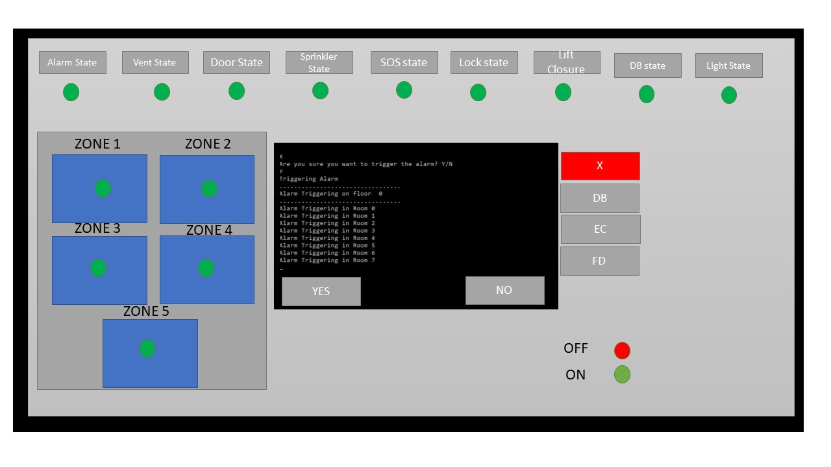

# Vents open



# Zone Information

*Figure 6*

This section provides the user with information regarding the alarm state of each zone within the building. (Figure 5)

Note Red = alarm NOT triggered Green = alarm triggered

# 

*Figure 7*

# Key

This (Figure 8) is an indicator to the user the meaning of each light, please note that these lights will never change.

Note Red = alarm NOT triggered Green = alarm triggered

# Alarm State

This is referring to the state of the sound alarm, once a fire is detected or a fire drill is being run this will become green indicating that the sound alarm is active, please note that this is an indicator of the sound alarm and not the fire alarm system in general. If this is red, it means that there is no sound alarm running.

*Figure 8*

# Vent State

*Figure 9*

This is referring to the state of the vents within the building once an alarm has been triggered, please note that this will be green regardless if you have vents disabled in some rooms and enabled in others. If this is red, it means that all vents are closed and there is no vent opening procedure running

# Door State

*Figure 10*

This is referring the state of the fire door closing procedure, please note that this is NOT the door locking procedure as the door locking procedure is done when the zone has been evacuated fully. If this is red it means that the door closing procedure is not occurring and fire doors will not be closing automatically, please note that this will be green regardless if some zones have this procedure deactivated and some zones have this feature activated.

# Sprinkler State

*Figure 11*

This is referring to the state of the sprinklers, if the light is indicated as green it means that the sprinkler system has done a scan of the rooms and is activated - please note that this will be green if activated regardless if some rooms have it deactivated.

# SOS State

*Figure 12*

This is referring to the state of emergency services being called – if the light is green a message has been sent to the local fire department with the location/time and potential reason of fire.



*Figure 13*

# Lock State

This is referring to the state of the procedure of locking off zones, this will only be activated after almost all other procedures due to the nature of it. If this light is indicated as green it means that a scan of every room has been completed (as well as a double check) in each zone and each door is locking, please note that this light will indicate as green regardless if some zones have been customized to not lock off.



*Figure 14*

# Lift closing State

This is referring to the state of lifts being opened and then deactivated, upon fire detection the fire alarm system will automatically bring lifts to the closest floor and then open the doors and deactivate the lifts. If the light is green, it means that all lifts have been brought to the closest floor opened their doors as well as deactivate them for usage.



*Figure 15*

# Database State

This is referring to the fire being logged in the database, if this is green it means that the fire has been logged.

# Directional Indicator State

*Figure 16*

This is referring to the state of the directional indicators being activated – upon fire detection lights will turn on directing personnel to the closet fire exit, if this light is green it means that the directional indicators are active.



*Figure 17*

# Fire Alarm Buttons

*Figure 18*

# Manual Activation

The big red X (Figure 18) activates a manual fire alarm, upon pressing this the user will be asked if they would like to run an automatic or manual fire alarm, then will be greeted by a confirmation message where they will have to either cancel the alarm or confirm it, if there is no response in 10 seconds the alarm will activate. This alarm will be automatic and will follow the configuration that is chosen by the user via the edit configuration function.

*Figure 19*

# View Database

*Figure 20*

The DB button (Figure 20) on the right hand side of the panel will open up the database of all recent fire drills and alarms, note that this can be enabled or disabled via the edit configuration. The database will display the time and date of the fire as well as a n optional reason (for drills etc.) (Figure 21)

# Edit Configuration

*Figure 21*

*Figure 22*

The edit configuration button will allow the user to disable or enable certain functions, a further explanation of this function is explained in 5, once pressed the terminal will cycle through each function asking the user if they want this function in the automatic fire alarm. (Figure 23)

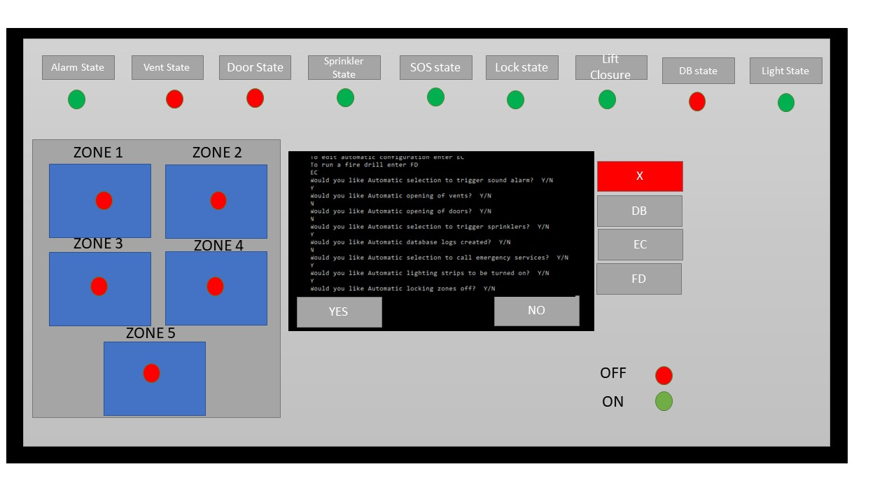

*Figure 23*

*Figure 24*



# Fire Drill

This button (Figure 24) will activate a fire drill, the user will have the choice of running manual or automatic (explained in 2), as well as a confirmation message, if the automatic function is selected functions such as SOS and sprinklers will not be activated to ensure that no damage is done. (Figure 25)



*Figure 25*

Chapter

2

Fire Alarm Activated

This chapter will explain the events that will occur once a fire alarm has been detected or manually activated, this also includes fire drills.

t

he fire alarm system can be activated in 3 ways, A fire being detected via smoke/heat detector, a manual activated via the admin panel or a break glass fire alarm, or by activated a fire drill via the admin panel.

Automatic

Once the fire alarm has been activated manually the user will be prompted with a confirmation message, if they do not reply to the message the alarm will activate, then the user will be prompted with a choice of manual or automatic fire alarm. This section will explain the automatic alarm. Please note that specific functions can be enabled or disabled via the edit configuration function explained in 4.

**How to start an automatic fire alarm**

1. Press X on the module
2. Confirm the alarm
3. Select A for automatic

Automatic Example

In the following example the fire alarm admin panel will look as following (Figure 25)

*Figure 25*

The images below (Figure 26,27,28) will describe what the software is doing as it is active.

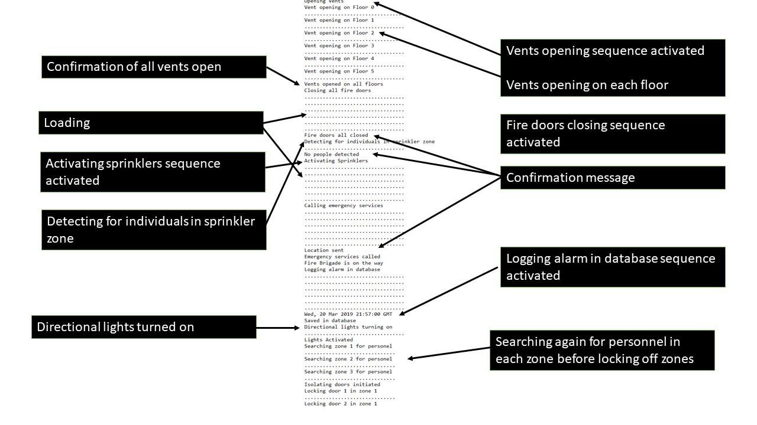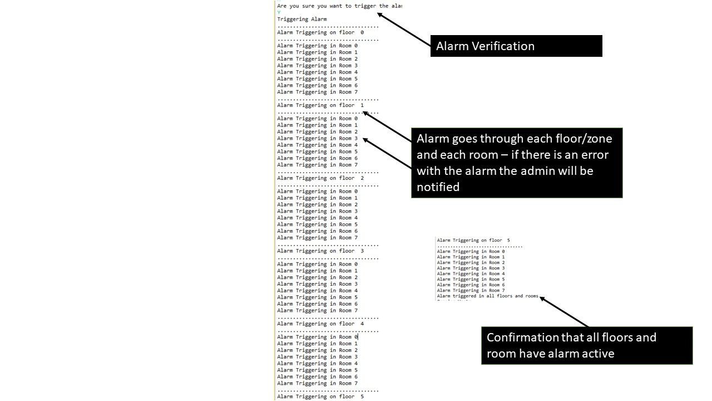

*Figure 27*

*Figure 26*

# 

*Figure 28*

During the activation of various functions, the panel will indicate what has been activated and what has not, the image below (Figure 29) should depict what your panel will look like during an alarm, subject to change depending on what functions are enabled and disabled.

# 

*Figure 29*

Manual

Once the fire alarm has been activated manually the user will be prompted with a confirmation message, if they do not reply to the message the alarm will activate, If the user selects manual they will be greeted by a confirmation message and then a cycle of each function asking if they want to trigger it or not, this is a list of each function that can be disabled/enabled

* Alarms
* Vents
* Automatic closing of doors in each specific room
* Sprinkler system in specific rooms
* Emergency services calling (SOS)
* Zone locking off
* Database logging
* Directional lighting

How to enter manual fire alarm

1. Enter your pin to unlock the console module
2. Press X to trigger a fire alarm
3. Confirm the alarm
4. Select ‘Manual’

Manual example

In this example the fire alarm admin panel will look like the image below (Figure 30)

*Figure 30*

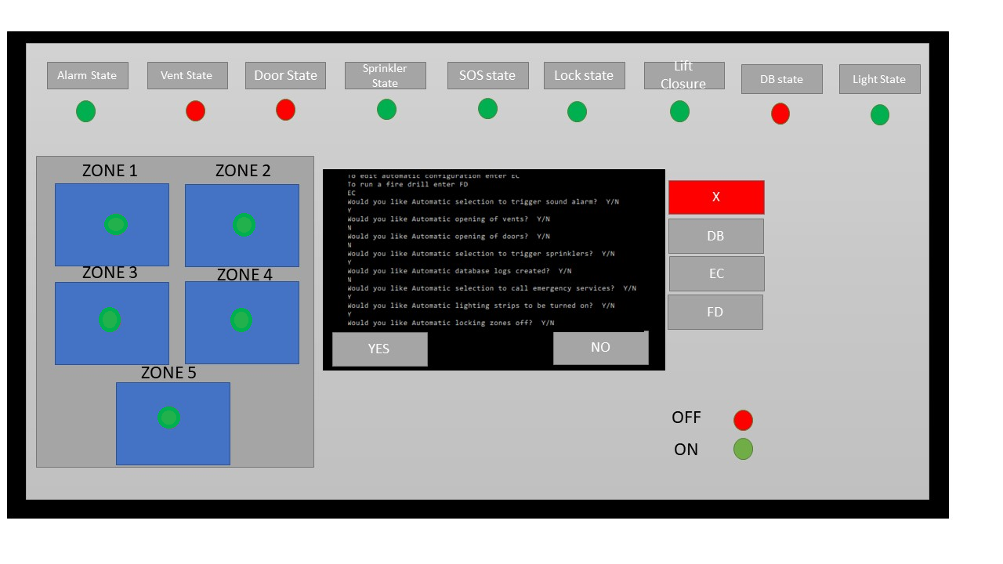

The images below are going to explain what is occurring while a manual fire alarm is active

(Figure 31,32,33)

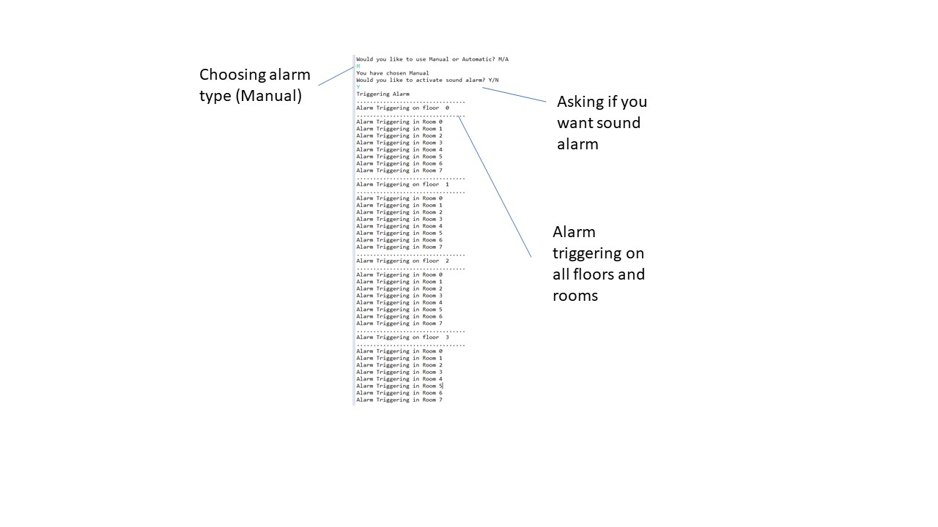

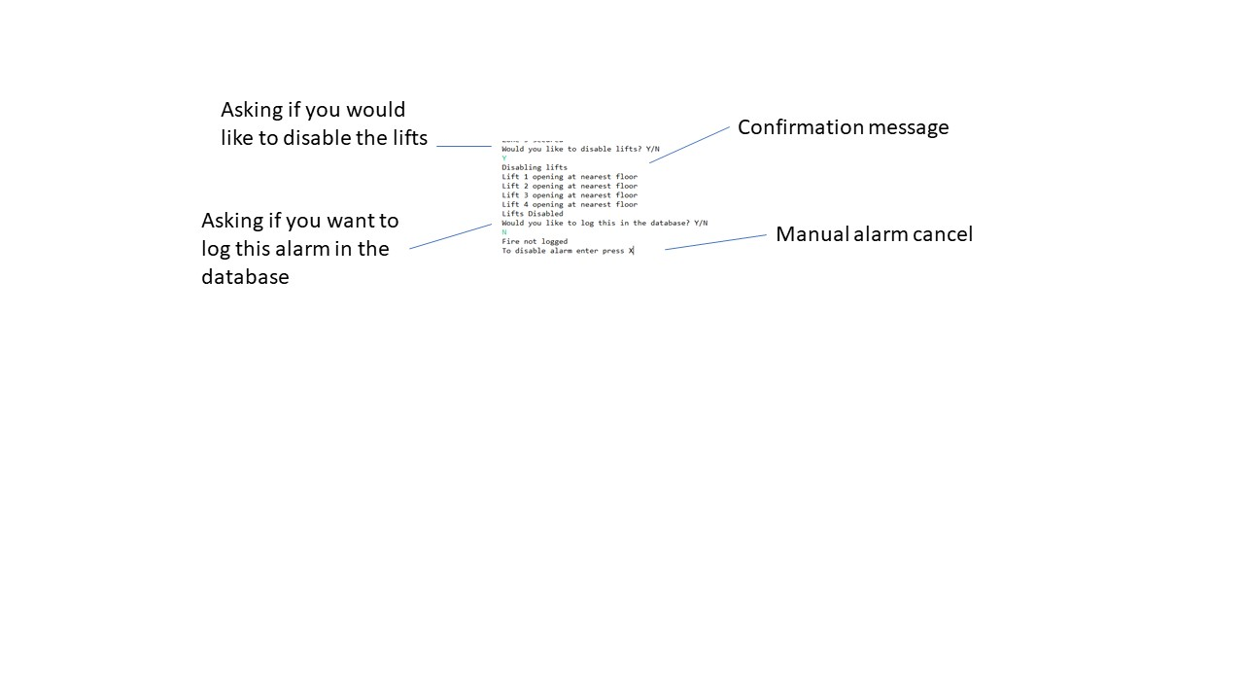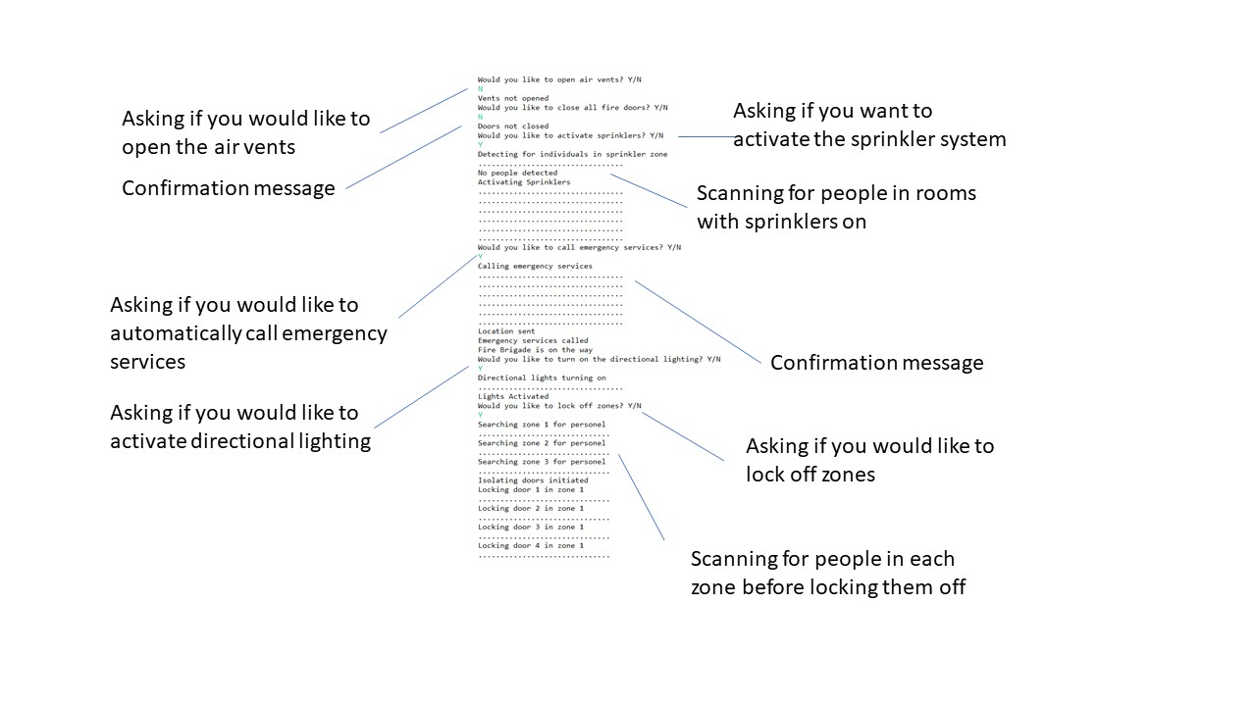

*Figure 33*

*Figure 32*

*Figure 31*

Running a fire Drill

Every unit of our fire alarm system comes installed with a fire drill function, this is entirely controlled manually from the fire panel.

For further information on manual and automatic please refer to chapter 2

To trigger a fire drill

1. Enter the FD function
2. Confirm the fire drill
3. Select Manual or automatic

Please note that you can cancel a fire drill at any time by pressing X

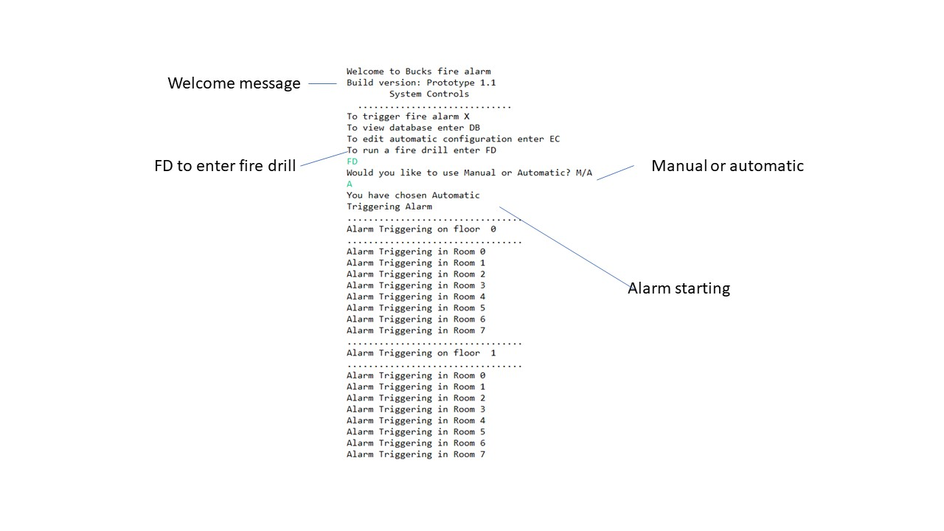

The image below is going to explain what is occurring during a fire drill (Figure 34)

*Figure 34*

Chapter

3

Database Utilization

This chapter will explain how to utilize the database function and how-to setup the database on a local drive or cloud drive.

t

he fire alarm system comes equipped with a database tool which can log each and every fire drill, alarm or test. The database is saved on the admin panel by default, but you can set it up to save on a local drive such as a USB or on the cloud.

How to setup USB database saving

1. Locate the USB input on the bottom of the fire alarm system module (Figure 35)
2. Input your USB drive
3. Open the Database function by selecting DB
4. Your database will be saved onto the USB in a .txt format

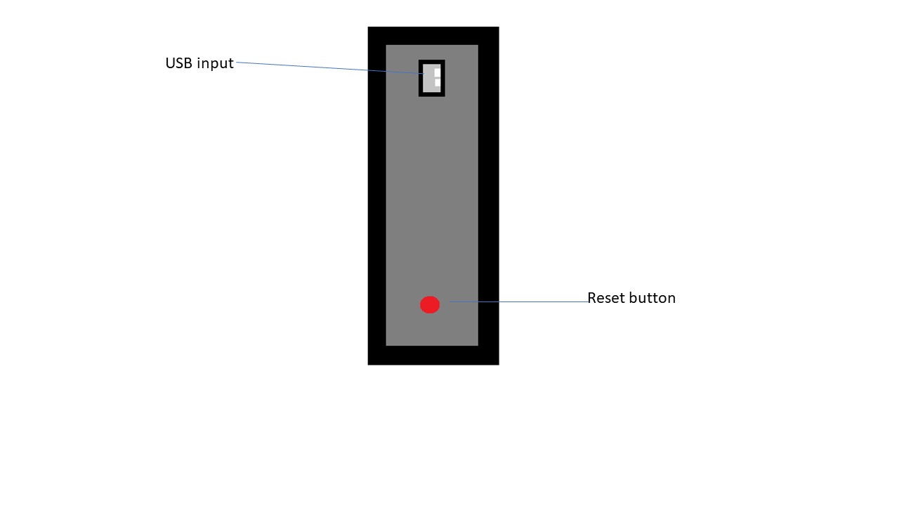

*Figure 35*

How to setup cloud database saving

1. Create an account and log into our website – <http://www.bucksfirealarms.com>
2. Navigate to Admin panel
3. Select “Automatically backup my database to the cloud
4. Enter the number displayed in the admin panel

Note – For this to work your fire admin panel must be in range of WiFi

Chapter

4

Edit Configuration

This chapter will explain how to edit the configuration of the automatic fire alarm.

t

he edit configuration is a function that comes with the fire control unit that allows you to edit the loadout of what the automatic fire detection system will do, you can disable or enable several functions that will run when a fire alarm is automatically detected or started from the fire control unit.

How to operate

1. Unlock the fire control module by entering your 6-digit pin

2. Select the EC function for edit configuration

3. Cycle through each function and select enable or disable to meet make your choice

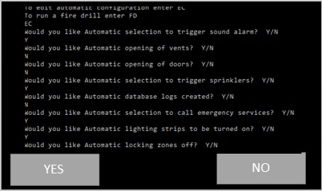

Note – to completely reset your configuration to the default you can press the ‘Reset’ button on the bottom of the device by using a paperclip.



*Figure 36*

Chapter

5

Error messages and Recovery Procedures

This chapter will explain what specific error messages mean and their potential affect as well as how to recover from the

E

rror messages are a part of every system, as much as we have tried to perfect our service there are a few error messages, however there are no errors that will stop the fire module from doing its intended purposes.

Error code: 101 No Wi-Fi access (Figure 37)

This error code is regarding the cloud backing up of the database, if you do not intent to back up your database you can ignore this. This error code is displaying as the module Is trying to upload your database onto the cloud however it cannot make a secure connection. This error will only occur if you have backed up your database to the cloud in the past. This can occur for many reasons:

- The module is out of Wi-Fi range

- The module cannot connect due to interfering microwave radiation

To fix this issue you should first try connecting to the Wi-Fi network via another device such as a mobile phone, if the phone also cannot connect try extending the range of the Wi-Fi signal by using a device such as a repeater, or if there are any large electronic devices (such as a fridge) in between the router and admin panel try relocating the router or admin panel. If these do not fix your issue press the RESET button on the bottom of the device (Figure 35)

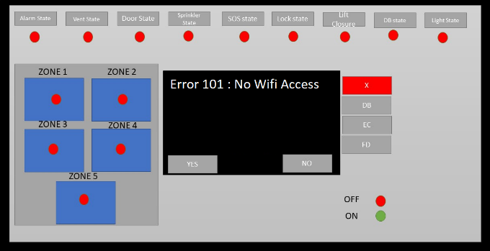

*Figure 37*

Error code: 007 Alarm not connected (Figure 38)

This error is regarding the hardware of the fire alarms themselves, this occurs when the admin panel is not connected to any alarms, this error is critical and if you have this please report it immediately to our 24/7 customer support and we will send over a technician immediately. (See chapter 1)

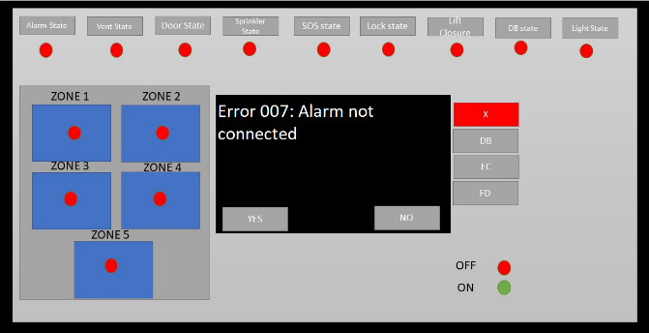

*Figure 38*

Error code: 212 Module not connected (Figure 39)

This error is regarding one or more of the modules (Vents, door locking, etc.) not being configured or connected correctly, if your fire alarm system in your building does not contain one of the modules you can ignore this error, however if you are receiving this error and you have the contextual module please call our 24/7 customer support and we will send over a technician as soon as possible. (See chapter 1)

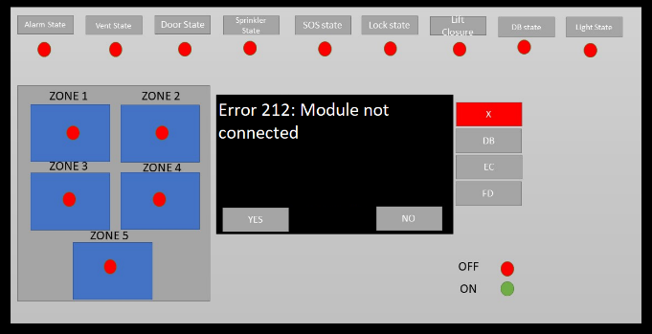

*Figure 39*

Error code: 333 Database connection error (Figure 40)

This error is due to the system not being able to write alarm information into the database, this is likely due to the system clock being out of sync.

To fix this error you must reset the button by pressing the reset key at the bottom of the module (Figure 36)

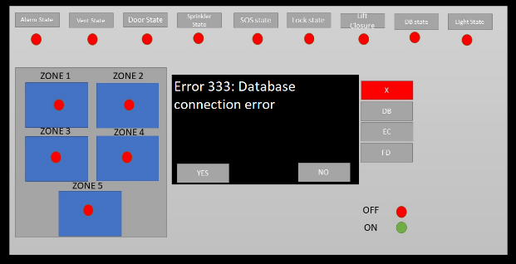

*Figure 40*

Error code 123: Incorrect configuration set (Figure 41)

This error will occur when you have used the edit configuration function to change the automatic fire alarm to not trigger any function.

To resolve this error, you must navigate to the edit configuration tool and enable some functions. (See chapter 4)

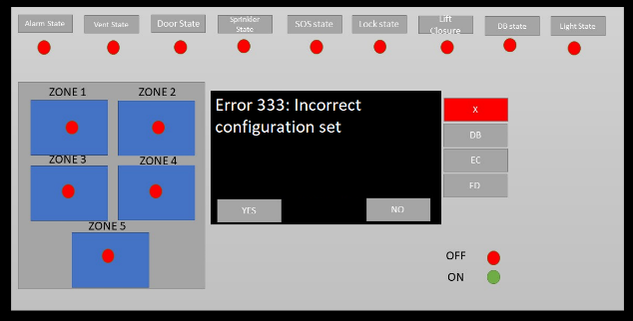

*Figure 41*

Error 013: Incorrect Pin (Figure 42)

This error will occur when you have entered your pin incorrectly while unlocking the module.

To resolve this try re-entering your pin, if you have forgotten it please contact our 24/7 technical support (See chapter 6)

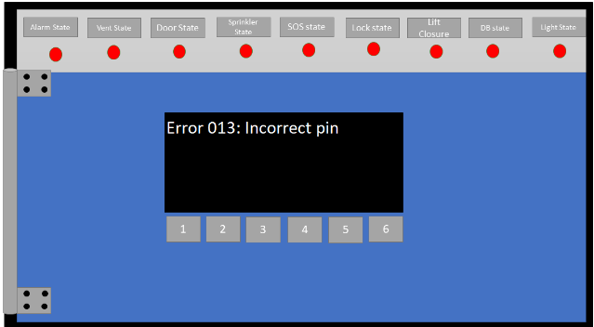

*Figure 42*

Chapter

6

Forgot My Pin

This chapter will explain how to reset your pin if you have forgotten it.

I

f you have forgotten your pin there is no need to worry, your manual fire alarm activation will still work by pressing the big red X (Figure 18), however you must contact our technical support as soon as possible.

How to recover your pin

If you have forgotten your pin you must call our 24-hour technical support line (020123456789), to provide you with a reset code and new pin we will need the serial number of the device and we will look at our database and recover your passcode. If for some reason you cannot use a phone (we do not recommend this due to potential risk of yourselves) you can email us at [pinhelp@bucksfirealarms.com](mailto:pinhelp@bucksfirealarms.com) with your serial number and name.

Our email service will respond automatically with your pin code if you have sent the correct serial number and name.

Format for email:

NAME:

SERIAL NUMBERL:

Please stick to this format to ensure minimal downtime of your fire alarm admin panel

24 Hour support line – 020123456789

Email - [pinhelp@bucksfirealarms.com](mailto:pinhelp@bucksfirealarms.com)

Chapter

7

How to Install the Admin Panel

This chapter will explain how to install the Admin panel and how to initially set it up.

B

ucks fire alarms are easy to setup and install, we offer setup on delivery free of charge however if you have moved the fire alarm system module and wish to reinstall it this chapter will explain the process.

Our fire alarms come with 2 main pieces of hardware: A relay module and an admin panel. All of the functions are wired into the relay module which is then connected to the back of the admin panel.

Note – You must comply and adhere to the government health and safety requirements while installing these modules, please visit http://www.healthandsafety.gov.uk before starting.

How to setup the Relay Module

Tools needed

Phillips flathead screwdriver

4x 4mm flathead screw

Cable lead to admin panel

All tools provided with package

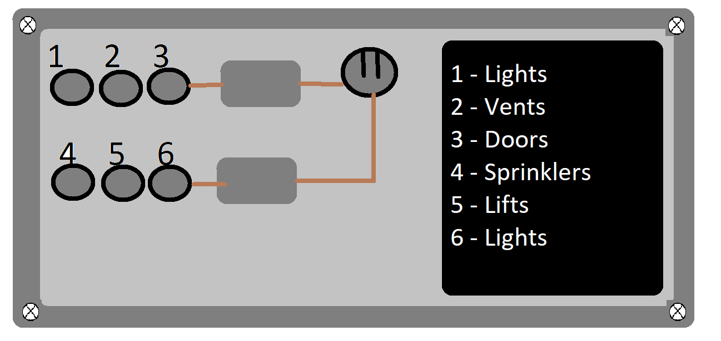

*Figure 43*

How to install the Relay Module

1. Locate a suitable place to install the relay module, ensure it is at least within 3 meters of the admin panel
2. Screw the relay module into the wall by using the Philips flathead screwdriver and screws
3. Plug in each corresponding cable (see key)
4. Connect the relay module to the admin panel

Relay Module explained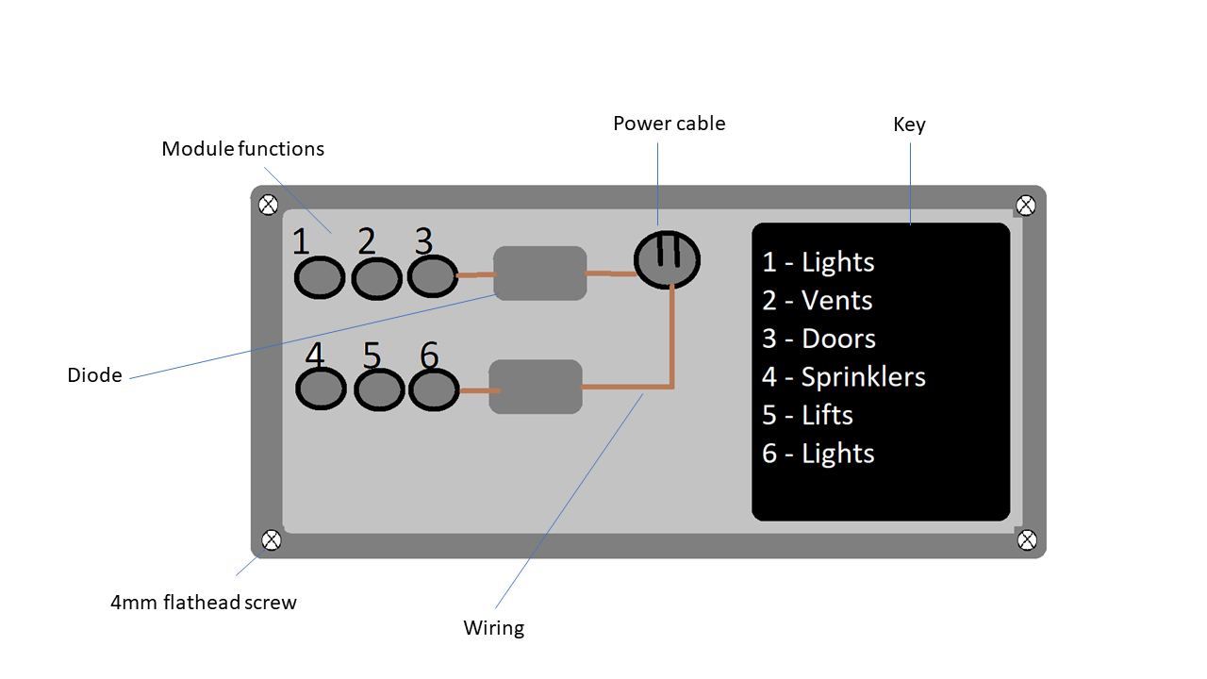

*Figure 44*

How to Install the Admin Panel

Tools needed

Phillips flathead screwdriver

4x 4mm flathead screw

Cable lead to relay module

CAT 5 RJ45 cable

Power Cable

All tools provided with package

# Back

*Figure 45*

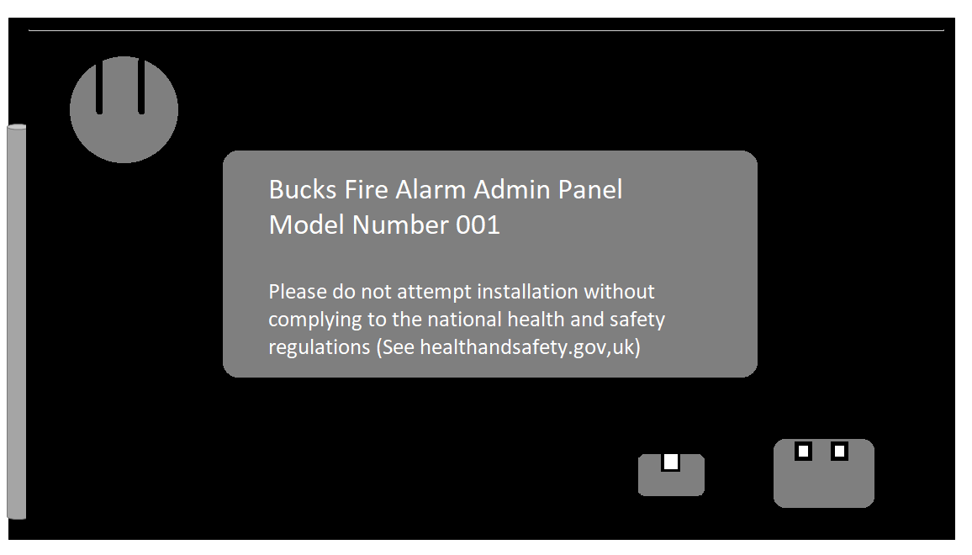

# Front

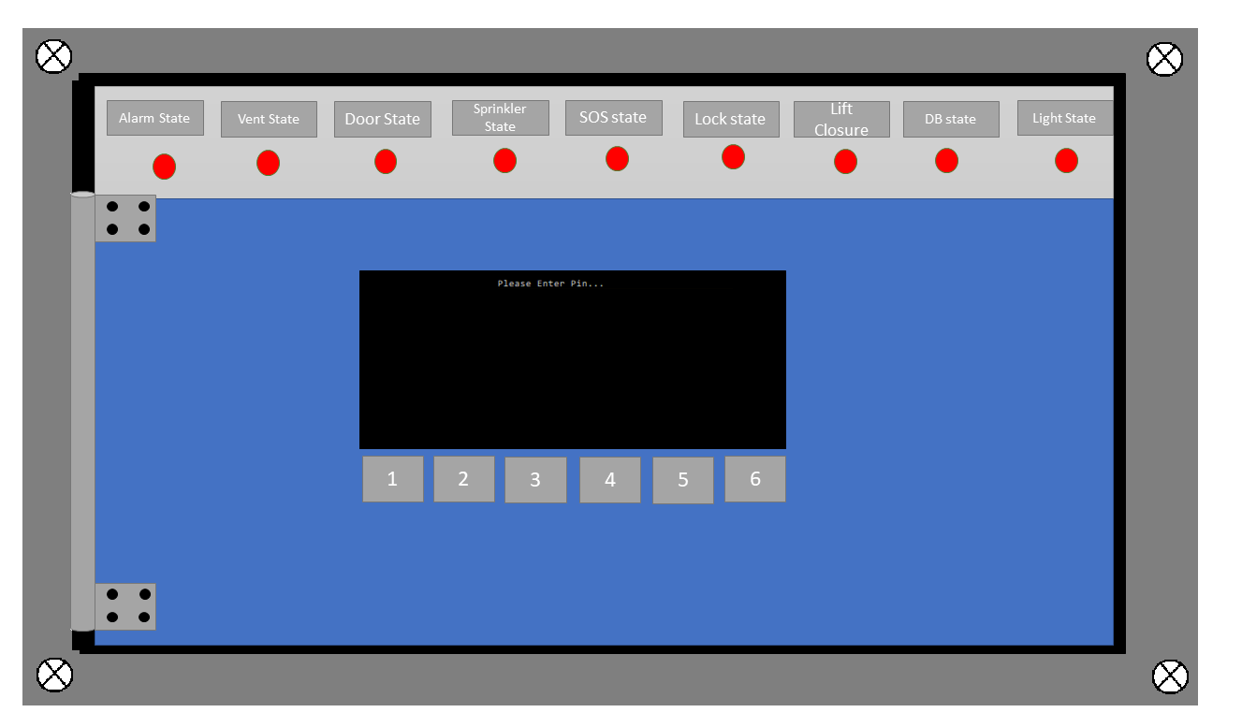

*Figure 46*

How to install the Admin Panel

1. Locate a suitable place (ensure you are not near any large electronic devices to reduce interference)
2. Plug in the relay module
3. Plug in the Rj45 cable (optional)
4. Screw the device in

# Back panel explained

*Figure 47*

